HONG KONG AIR CADET CORPS 香港航空青年團

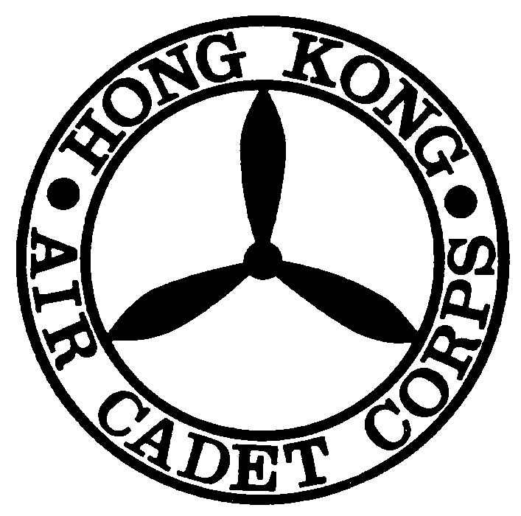
Application for Cash Advance Form 預支費用申請表格

This Application must reach Headquarters One Month before the Activity Date
此申請表格必須在活動日期前一個月到達總部

Please read notes before completion 填寫前請先閱讀摘要

Serial No. ___________
Day of Application (申請日期): ______________________
Applying Unit (申請單位): _________________________________________________________________
Title of Activity (活動名稱): _________________________________________________________________

Nature of Activity (活動性質): _________________________________________________________________
Duration of Activity (活動時限): From (由) _____________________ To (至)________________________
Reasons for Applying (申請原因):
Responsible Officer (負責長官): ____________________________________________________________

Signature Name Rank
Contact Person (聯絡人): ________________________Contact Phone No. (聯絡電話):______________

Cheque Payee (支票受款人) : ___________________________ Amount (金額) : _______________

Approval Officer:
(批核長官) Signature Name Rank Contact Phone No. Date

Received by :
(收款人簽名) Signature Name Rank Contact Phone No. Date

Notes:
- All application must be approved by Commanding Officer
- Please attach BUDGET PLAN REPORT.
- Please return the cash and expenditure form to Headquarters WITHIN ONE MONTH from the activity
completion date.

Checked by:
(AA2) (Date)

Approved by:
(CO) (Date)

