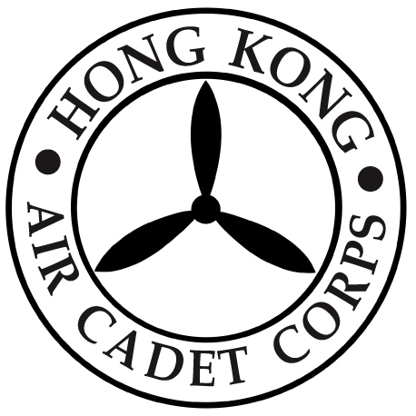

HONG KONG AIR CADET CORPS

From : SO  Ref : GR23_006 | To : All Members  Cc :
Tel : 2712 8900  Fax : 2715 6944 | Date: 1 April 2023

航情

The new issue of 航情Vol. 17 has been published. Members are welcome to collect at the Headquarters.

Thank you for your attention.

Toby NG
Staff Officer
