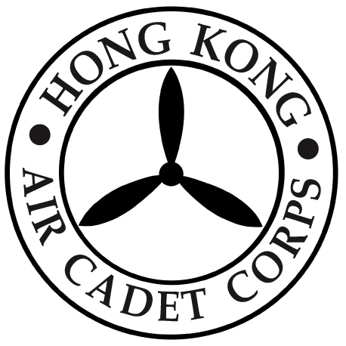
HONG KONG AIR CADET CORPS

NOMINATION FOR MEMBERS OF THE EXECUTIVE BOARD 2022/24

I hereby propose the following Member of the Corps eligible for election under the Articles of Association to be Member of the Executive Board for 2022/24.

PROPOSER’S NAME:

PROPOSER’S SIGNATURE:

SECONDER’S NAME:

SECONDER’S SIGNATURE:

Acceptance of nomination by the nominee:

- Member
Nominee’s Signature:
Nominee’s Name:

Please return this form, when completed, on or before 1800 hours, Friday, 2 December 2022 to the Honorary Secretary (Attn: Administrative Manager, HQ).

