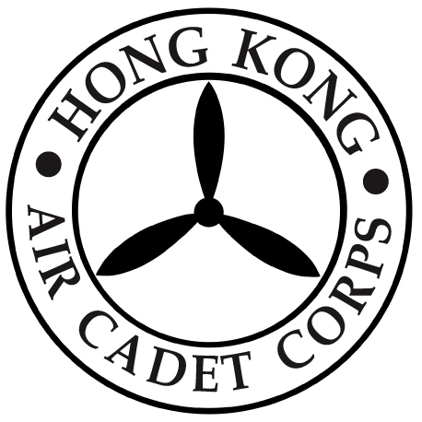
HONG KONG AIR CADET CORPS

Proxy Form for the Annual General Meeting Scheduled
for Thursday, 8 December 2022

To: Administrative Manager
Headquarters
Hong Kong Air Cadet Corps
Sung Wong Toi Road,
Kowloon.

To: Honorary Secretary,

I, _____________(Name in Block Letter) of (Unit) ,
being a Voting Member of the Corps, hereby appoint
(Name in Block Letter) of (Unit), as my proxy to vote for me on my behalf at the Annual General Meeting of the Corps to be held on the 8th day of December 2022, and at any adjournment thereof.

Signed this day of 2022

Signature of the Member

Important Note: Please return the ORIGINAL of this proxy form (with signature) by post or by hand to HQ, HKACC on or before 1300 hrs, 5th December 2022 (Monday) per the Articles of Association of the Hong Kong Air Cadet Corps (Companies Ordinance Cap.32).

