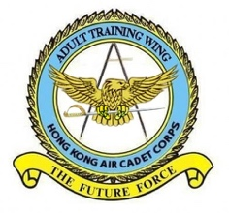 | 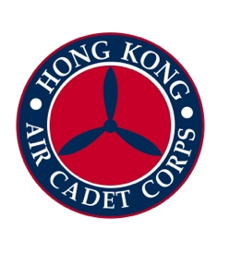 | 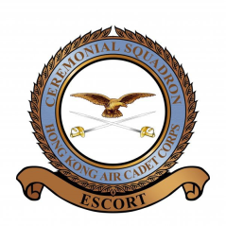

Hong Kong Air Cadet Corps
Training Group Joint Unit
Passing Out Parade 2016
No. 37 OCTC / No. 18 RITC / DSVS 14 / C Sqn

REPLY SLIP
PLEASE REPLY ON OR BEFORE 8 February 2017 (2359 hours)
To: Working Group of Training Group Passing Out Parade cum Graduation Dinner
Email add.: hkacc.trg.2017pop@outlook.com
Part A

I SHALL / SHALLNOT* attend the Passing Out Parade.

Please reserve |  | Seat(s) for me. Details of myself (and my guests) are as below:

 | Rank | Name | Member | Guest | Disciplined Force or other units(s) (e.g. Police, CAS)
1.
2.
3.

