HONG KONG AIR CADET CORPS
From : Flag Day 2016 Organizing Committee | To : All members  Cc : HQ, HKACC Website
Email : hkacc.fd2016@yahoo.com | To : All members  Cc : HQ, HKACC Website
Ref : fd2016/005 | Date : 12 October 2016

HKACC Flag Day 2016 - Sales of Souvenir

There is limited quantity of Flag Day 2016 souvenir available for selling.
The sales will be first come first serve since the quantity is limited.
All the sales amount will be donated to the account of Flag Day 2016

Payment could be made direct deposits to HSBC bank account “808-620280-005”
(please return bank pay-in slips for our records).

Flag Day 2016 – Plastic Folder (220smm x 309mm)

HK$ 5.00 per piece
Buy 2 pieces get 1 free

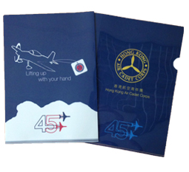

*Offer is valid on/before 22-Oct-2016

If you have any query, please feel free to contact the undersigned by email – peggytamsl@gmail.com

Peggy S L Tam
Squadron Leader
Project Manager, Flag Day 2016

HONG KONG AIR CADET CORPS

HKACC Flag Day 2016 - Sales of Souvenir
Order Form

I would like to order the following quantity:

Item | Qty | Amount | Extended Amount
Plastic Folder (220smm x 309mm)
 |  | Total

Name: ________________________
Rank: _________________________
Sqn / Unit: _____________________
Contact Tel No.: _________________

I would like to collect this order on _____________________

Completed form please send to: hkacc.fd2016@yahoo.com

